**Team Name**: Hack Elite

**Product Name**: Student Heal

**Product Description**:

An android application to help students make their education a wholesome process with proper consideration given to their bodily health and even mind health!

This app is gives students a platform to plan their lifestyle such that it incorporates exercises, rest and routinely health check alongside scheduling their academic needs.

**Tech Stack**: Kotlin and Java

**IDE**: Android Studio

**Project Directory**

We have added the android studio project folder for each feature we implemented into the main folder “HackElite”

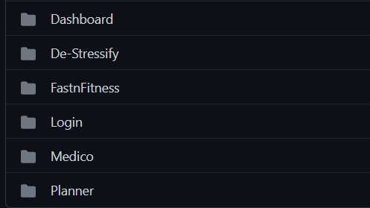

Under each features folder you can find the xml documents and build gradle files associated to them.(as below for de-stressify folder)

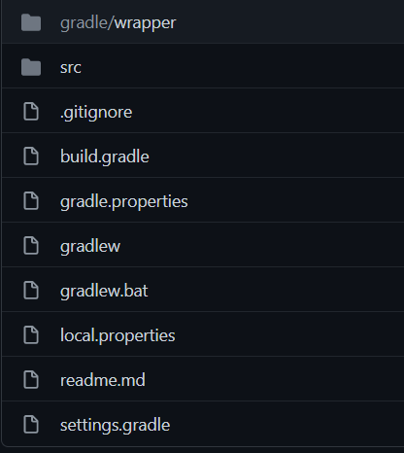

**Running the Application**

Kindly download the apk files of the features developed from the folder given below onto your android device, after accepting installation you can run them like any app.

Link:

<https://drive.google.com/drive/folders/1Xg0LRViyzZXlqgsq92GPhhJYbK_d9QYo?usp=sharing>

**Viewing the Demo Videos**

To view the working of these features developed go to link below:

<https://drive.google.com/drive/folders/1mkRSjL3muyXp6Cjtk_9vGTmTRkVZDFyh?usp=sharing>

**Checkout the Project PPT:**

<https://drive.google.com/file/d/12ILq29vpiBnw32FcKik6hqy294w5EjIR/view?usp=sharing>